Group Members

No | Roll No. | Name | Responsibilities
1 | 2223-4CS-92 | Nan Shwe Yi Phue | Source Code,Database Schema,ppt
2 | 2223-4CS-62 | Nan Aine Lin Hnin Chel | Source Code,Database Schema,ppt
3 | 2223-4CS-44 | Nan Thazin Myint | SourceCode,Sequence Diagram,ppt
4 | 2223-4CS-46 | Mi Thin Ya Na Hlaing | Sequence Diagram,Word Report,ppt
5 | 2223-4CS-110 | Ma Kyal Sin Win | Flow Chart,Use Case Diagram,ppt
6 | 2223-4CS-54 | Ma Than Than Htet | Source Code,Flow Chart,ppt
7 | 2223-4CS-57 | Ma Chit Thazin Soe | Word Report,Use Case Diagram,ppt

Supervised By
Daw Nan Nu Nu Kyi
Faculty of Information Science

University Of Computer Studies (Hpa-An)

Contents

Chapter (1) Introduction Pages
Abstract 3
1.1 Introduction 3
1.2 Scope 4
1.3 Problem Statement 4
1.4 Motivation 5
1.5 Project Objectives 5
1.6 Background Technology 6
Chapter (2) System Design
2.1 Database Schema 7
2.2 Use Case Diagram 10
2.3 System Flow Diagram 12
Chapter (3) Project Implementation 15
Chapter (4) Conclusion and Reference 30

Chapter (1)
Introduction

Abstract
The Travel Package and Itinerary Recommendation System for Hpa-an Tourism is a modern web-based solution designed to simplify tour package booking and itinerary management for tourists visiting Hpa-An. It replaces traditional booking methods, such as phone inquiries and physical visits, with a convenient online platform. Travelers can view available tour packages, receive suitable itinerary recommendations, and make bookings easily. At the same time, administrators can manage customer information, tour packages, schedules, and booking records through a centralized system. The system stores customer and booking information in a central database, helping reduce paperwork, staff workload, and human errors. It also helps prevent double-booking and improves the accuracy and efficiency of booking processes. Overall, the system provides a user-friendly and organized platform that enhances tourism management and customer satisfaction in Hpa-An.

1.1 Introduction
The Travel Package and Itinerary Recommendation System for Hpa-an Tourism is a modern solution designed to simplify the package booking and itinerary management process for tourists visiting Hpa-an. It replaces traditional manual methods, such as phone inquiries and physical visits to travel agencies, which are often time-consuming and prone to human errors. Through this system, travelers can easily view available tour packages online, receive personalized itinerary recommendations, and complete package bookings seamlessly at any time. At the same time, it enables tourism operators and system administrators to manage customer profiles, organize daily schedules, track bookings, and prevent double-booking issues through a centralized platform. With digital recordkeeping, all customer information, itinerary details, and booking histories are stored securely in a central database, which significantly reduces staff workload, minimizes paperwork, and leads to faster and more accurate processing. By offering a user-friendly interface for both travelers and administrative staff, the system streamlines overall operations and enhances customer satisfaction across the Hpa-an tourism sector.

1.2 Scope
The scope of the project focuses on providing a comprehensive user-facing module designed to enhance the booking experience for travelers visiting Hpa-an. The system allows users to search and view detailed travel package information, including itineraries, destination highlights, pricing, and available schedules. Through an intuitive web interface, customers can easily browse various travel options and place package bookings online at their convenience, eliminating the need for physical visits or manual inquiries.
From an administrative perspective, the platform equips system administrators with full control over operational and booking management. Administrators can manage travel package details, set package pricing, update schedules, and maintain up-to-date destination information. Additionally, the system efficiently handles customer bookings by streamlining confirmation, modification, and cancellation processes. It securely stores customer personal information and booking histories within a central database, enabling administrators to generate insightful analytical reports for better operational decision-making.

1.3 Problem Statement
The current tourism sector in Hpa-an suffers from the lack of a proper system for managing travel packages, which leads to limited and unclear information about tourist destinations. Travelers often face significant difficulties during the booking process due to the low accessibility of travel services and destination details. Without a centralized online platform, visitors cannot easily search for packages, verify itineraries, or complete bookings conveniently, making overall travel planning cumbersome and restrictive.
Furthermore, traditional travel agency operations rely heavily on manual handling, which results in significant inefficiencies in managing customer and booking records. Manual operations are inherently prone to frequent errors, miscommunications, and processing delays when handling reservation schedules. These operational bottlenecks not only increase staff workload and administrative costs but also negatively affect customer satisfaction and impede the sustainable growth of Hpa-an tourism.

1.4 Motivation of the Project
The primary motivation for developing this system stems from the limitations observed in the current booking process, which is often handled through phone calls, social media messages, or manual communication. These traditional approaches are frequently inefficient and inconvenient for travelers seeking quick and reliable service. Furthermore, travel agencies that rely on manual record-keeping face significant difficulties in efficiently managing tour package listings, tracking customer bookings, and organizing travel schedules without errors or delays.
At the same time, the steady increase in the number of tourists visiting Hpa-an creates a growing demand for a more organized, reliable, and digital travel management system. To support this tourism growth, there is a clear need for a centralized platform that simplifies access to comprehensive travel information for visitors while dramatically improving the operational management of travel services for local operators.

1.5 Project Objectives
The main objective of this project is to provide an organized and efficient online system for managing travel packages and itinerary recommendations for Hpa-An tourism. It aims to minimize errors caused by manual booking, reduce paperwork, and save staff time while offering tourists convenient access to travel information.
Other objectives include:
- Ensuring all booking records and tour schedules are stored securely and are easily accessible.
- Providing a user-friendly interface so tourists can seamlessly search for packages and complete reservations online.
- Allowing administrators to manage travel packages, destination details, prices, and booking schedules efficiently.
- Offering comprehensive information on Hpa-An tourist attractions to promote regional tourism.
Overall, the system is designed to improve accuracy, efficiency, and accessibility in managing tour packages and itinerary planning for tourists and administrators.

1.6 Background Theory

Our Travel Package and Itinerary Recommendation System for Hpa-An Tourism is developed using PHP, a versatile and widely-used server-side scripting language.
- Frontend: The user interface is built using HTML, CSS, and JavaScript, providing a clean, responsive, and interactive experience for tourists and administrators.
- Backend: All server-side logic, including travel package recommendations, booking processing, and schedule management, is implemented using PHP.
- Database: A PostgreSQL database is used to securely store all essential data, such as package details, booking records, user profiles, and itinerary information.

Chapter (2)
System Design

2.1 Database Schema
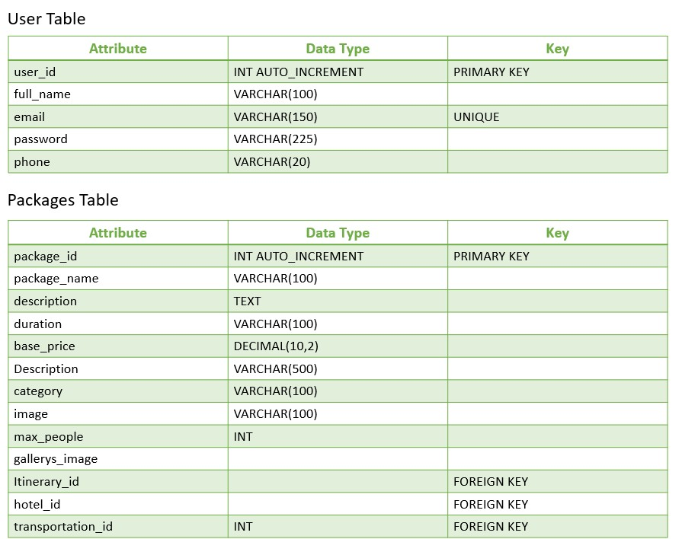

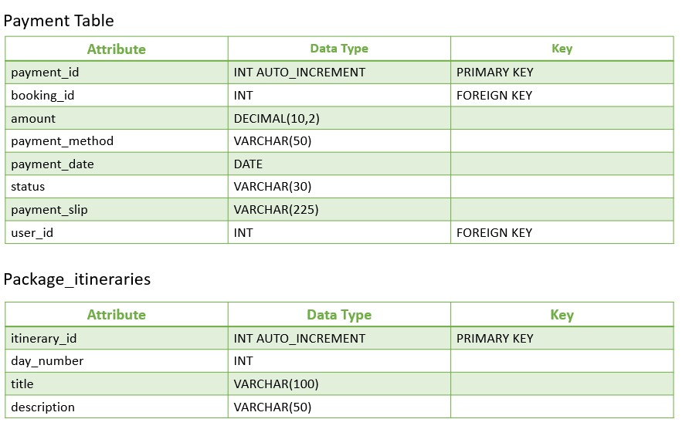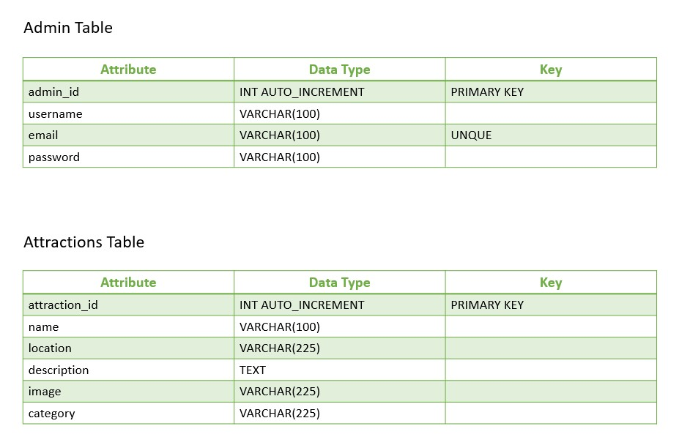

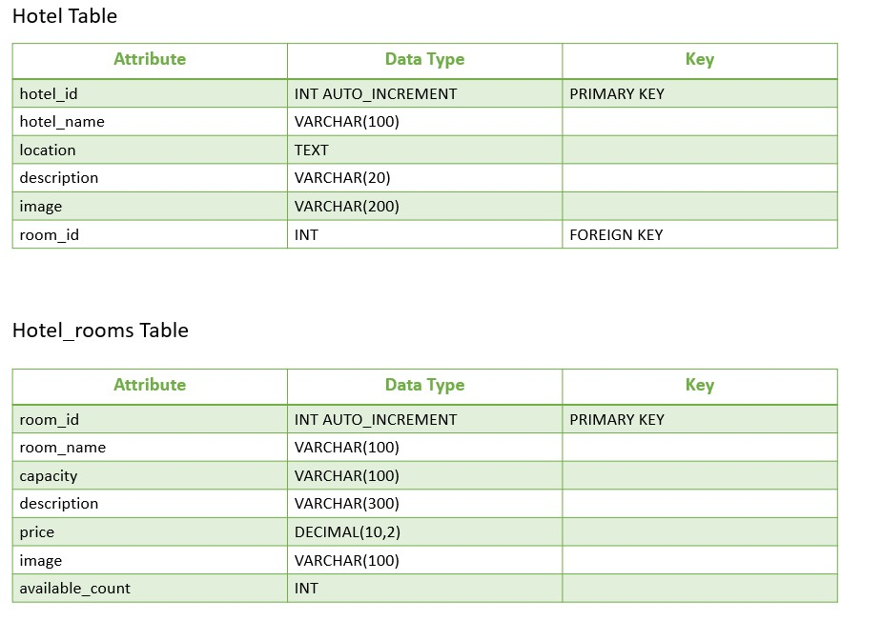

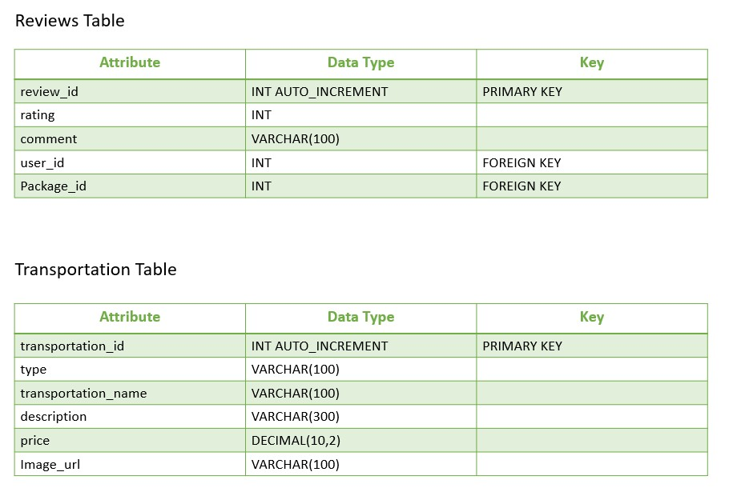

2.2 Use Case Diagram

Admin Use Case
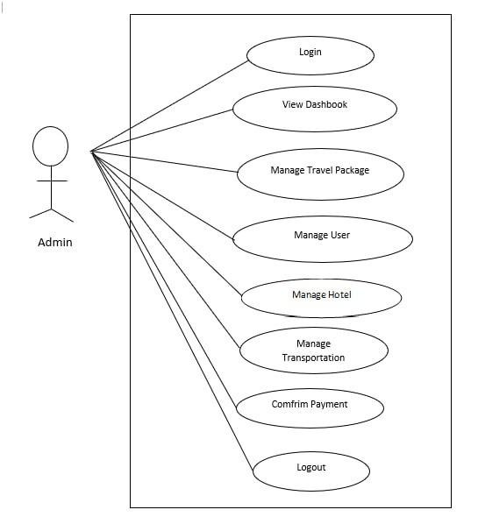

Figure(2.1): Use Case Diagram for Admin

User Use Case
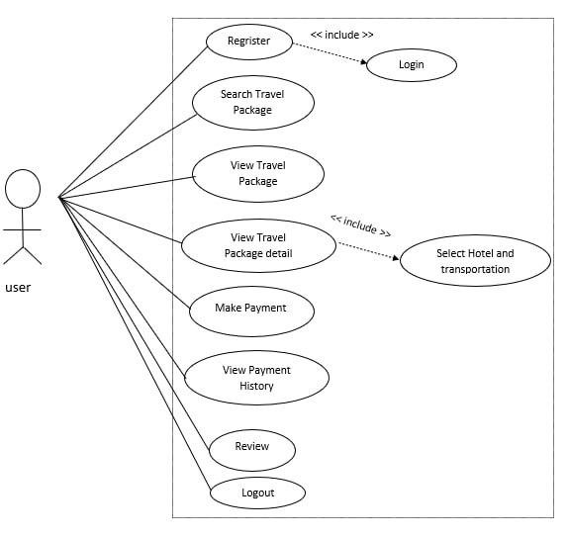
Figure(2.2): Use Case Diagram for User

2.3 System Flow Diagram
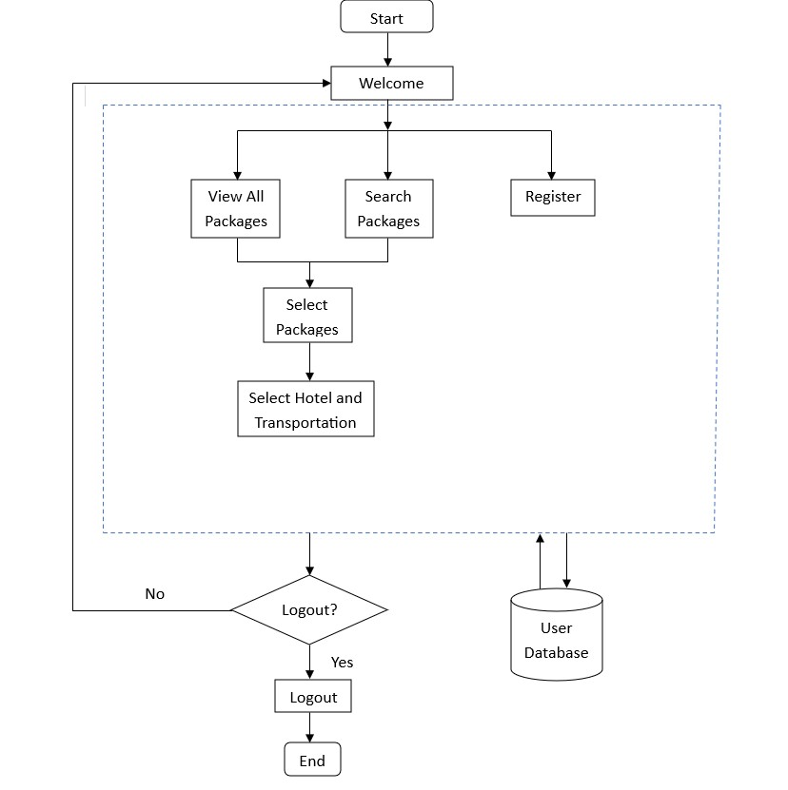

Figure(2.3): System Flow Diagram For Guest User

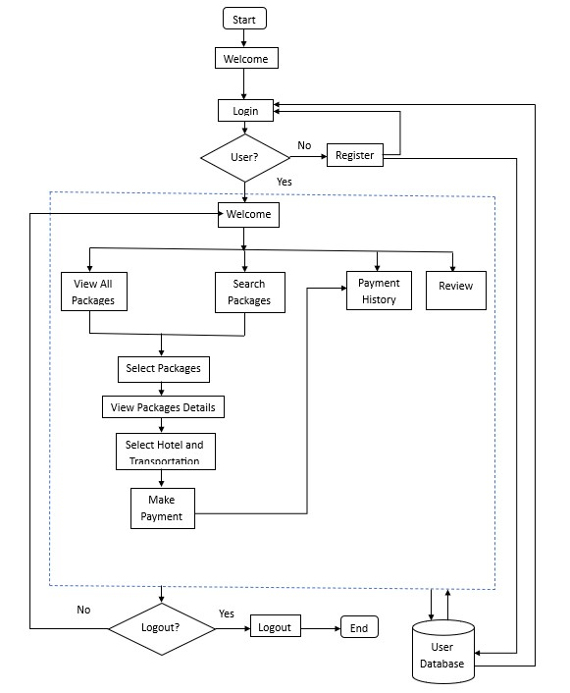

Figure(2.4): System Flow Diagram For Login User

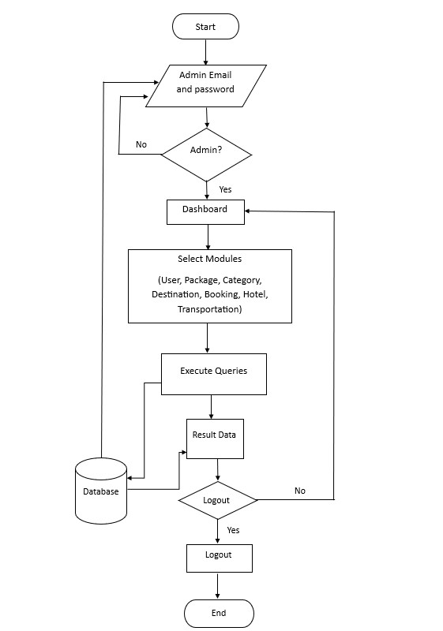

Figure(2.5): System Flow Diagram For Admin

Chapter (3)

Project Implementation

Admin Sign in Page
In this chapter, the implementation details are described as follows:
In Figure(3.1), the Admin of this system could login into this page by entering username and password.
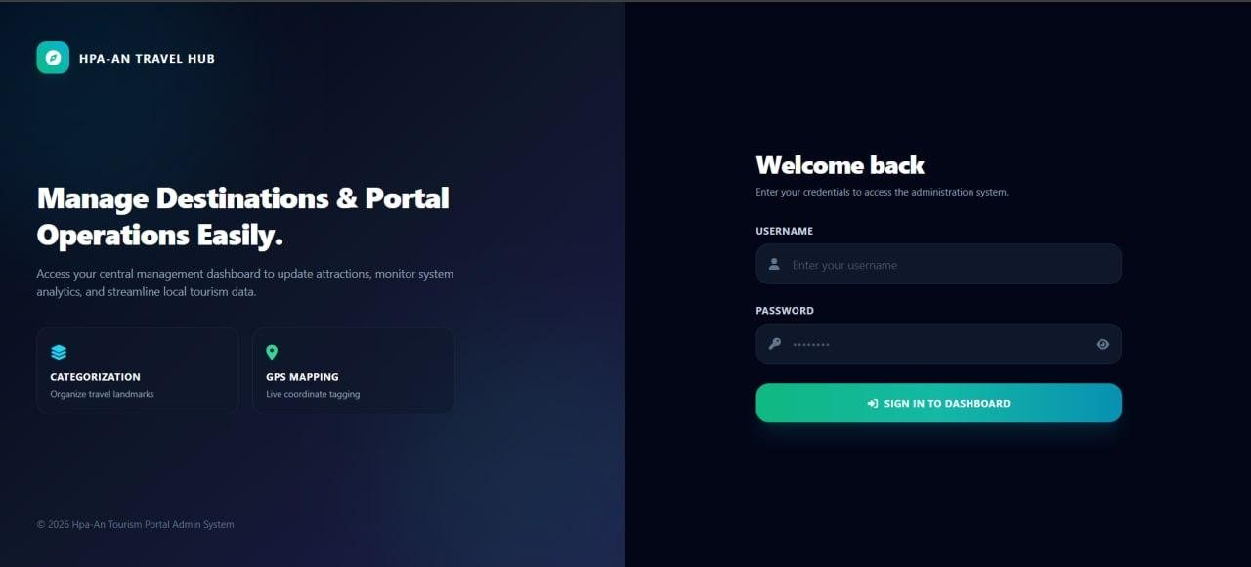
Figure(3.1): Admin Sign in Page

Admin Dashboard Page
After login, the Admin could be found the admin dashboard as shown in Figure(3.2).
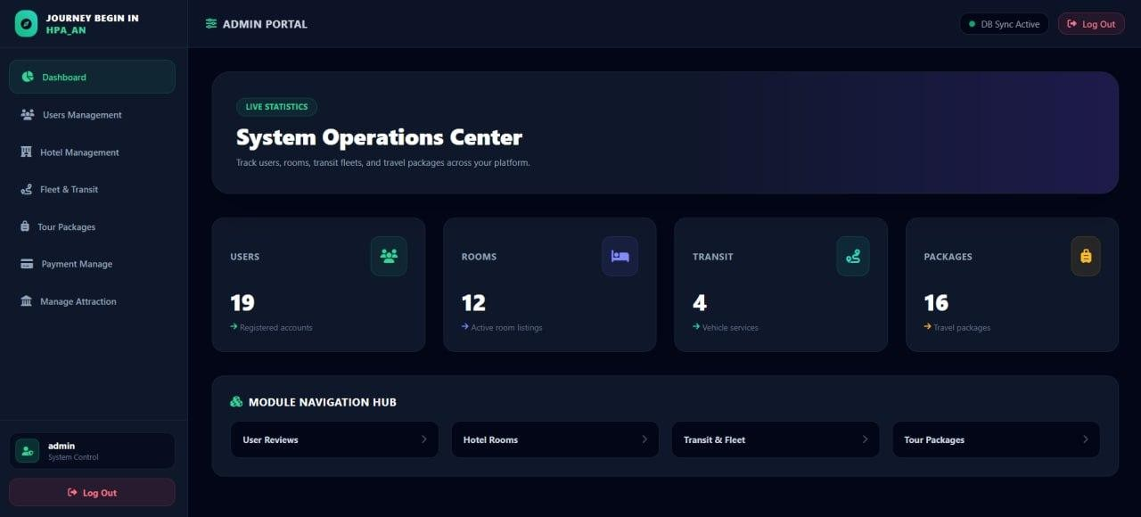

Figure(3.2): Admin Dashboard Page

Manage User Page
In Figure(3.3), the admin can manage users, such as deleting users, and view the number of user logins.
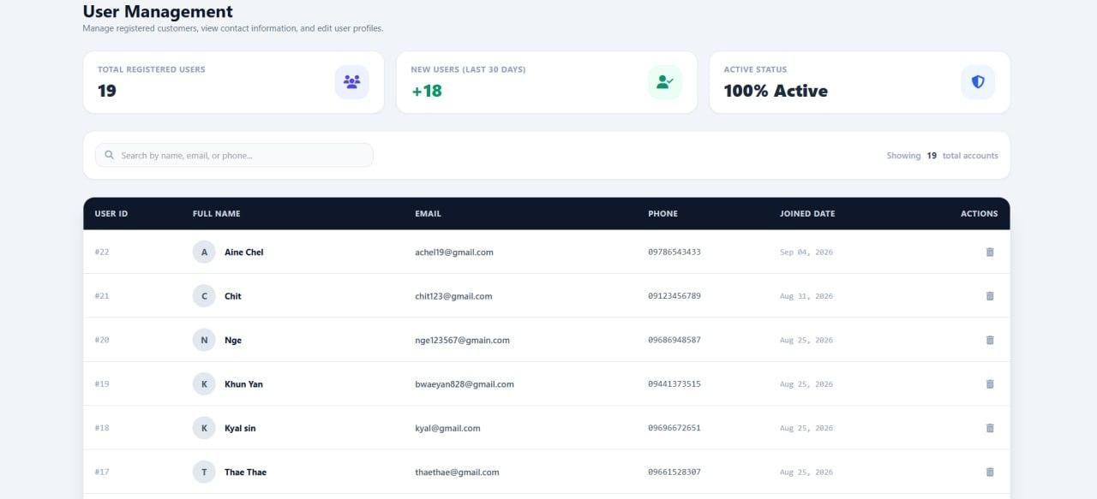
Figure(3.3): Manage User Page

Manage Hotel
In this Figure(3.4), the administrator can manage hotel information, including adding, updating, and deleting hotel records.
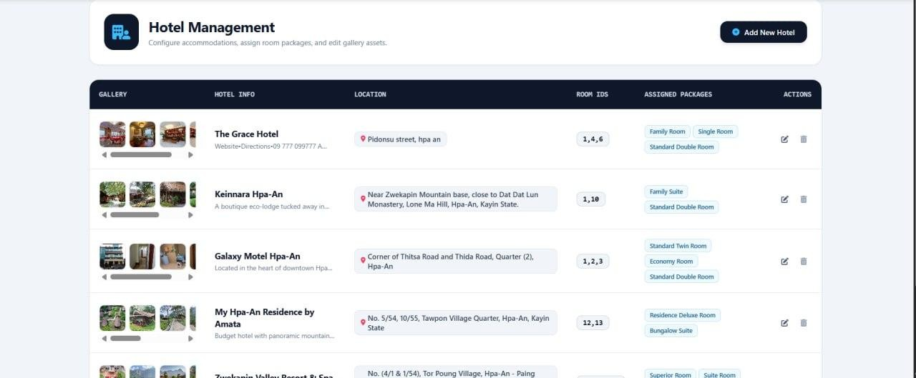

Figure(3.4): Manage Hotel

Manage Transportation Page
In this Figure(3.5), the administrator can manage Transportation information, including adding, updating, and deleting Transportation records.
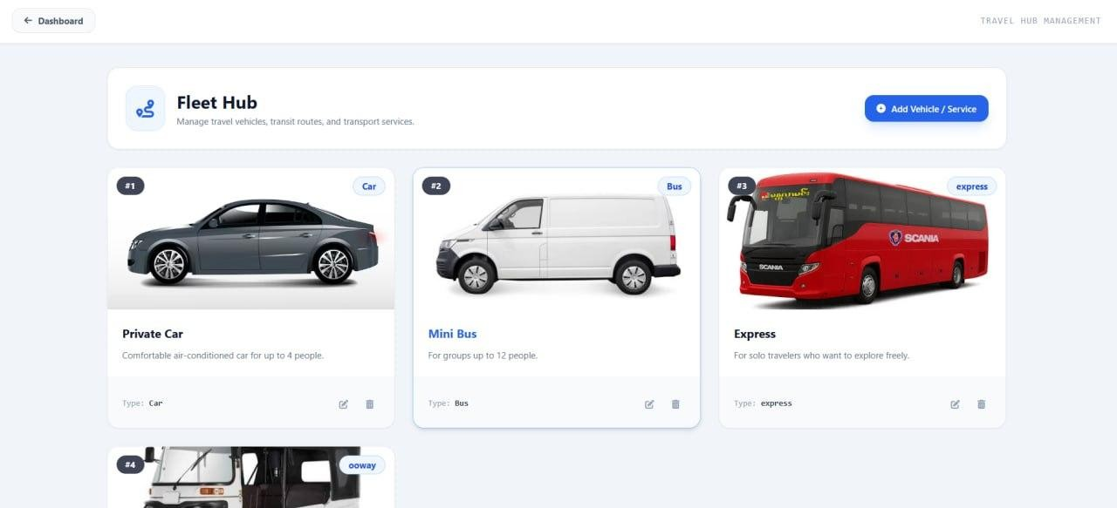
Figure(3.5): Manage Transportation Page

Manage Travel Package Page
The administrator can manage Travel Package information, including adding, updating, and deleting Travel Package records in Figure(3.6).
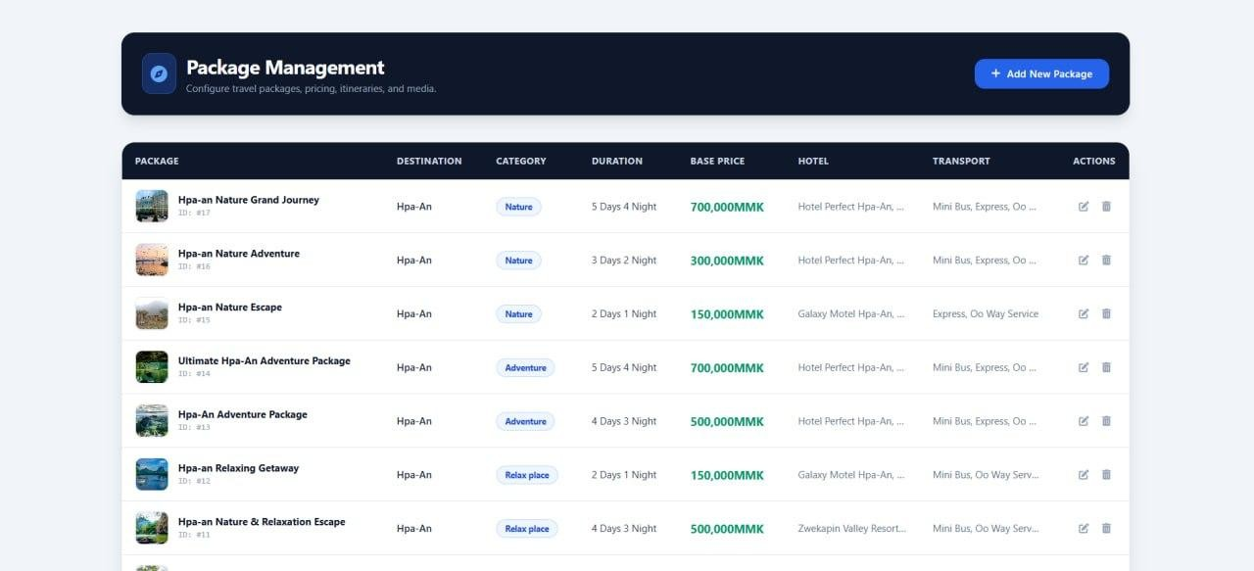
Figure(3.6): Manage Travel Package Page

Confirm Payment Page
In this Figure(3.7), the administrator can view the payment history and manage user payments by approving or rejecting payment requests.
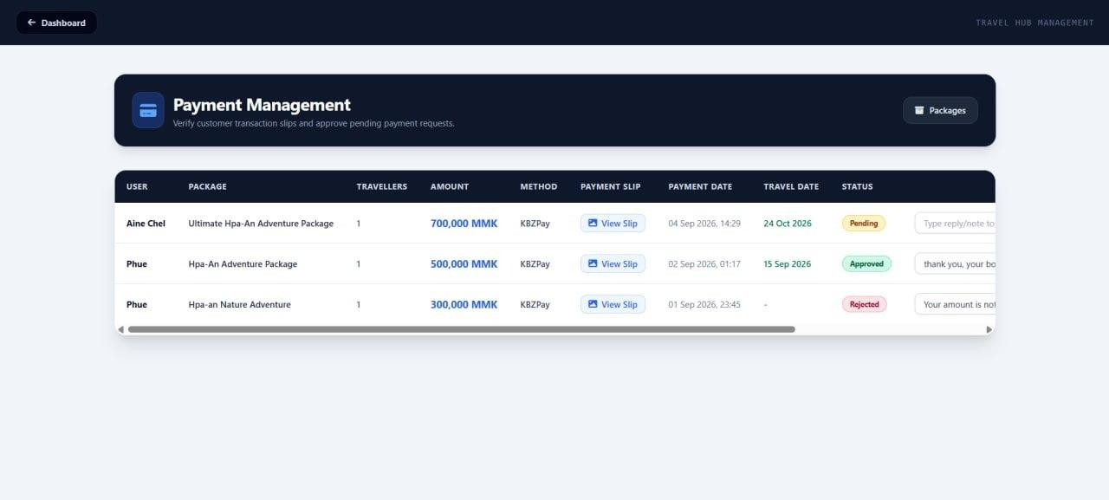
Figure(3.7): Confirm Payment Page

Management Attraction Page
In this Figure(3.8), the administrator can manage attraction information, including adding, updating, and deleting attraction records. The administrator can also view the total number of destinations and attraction categories.
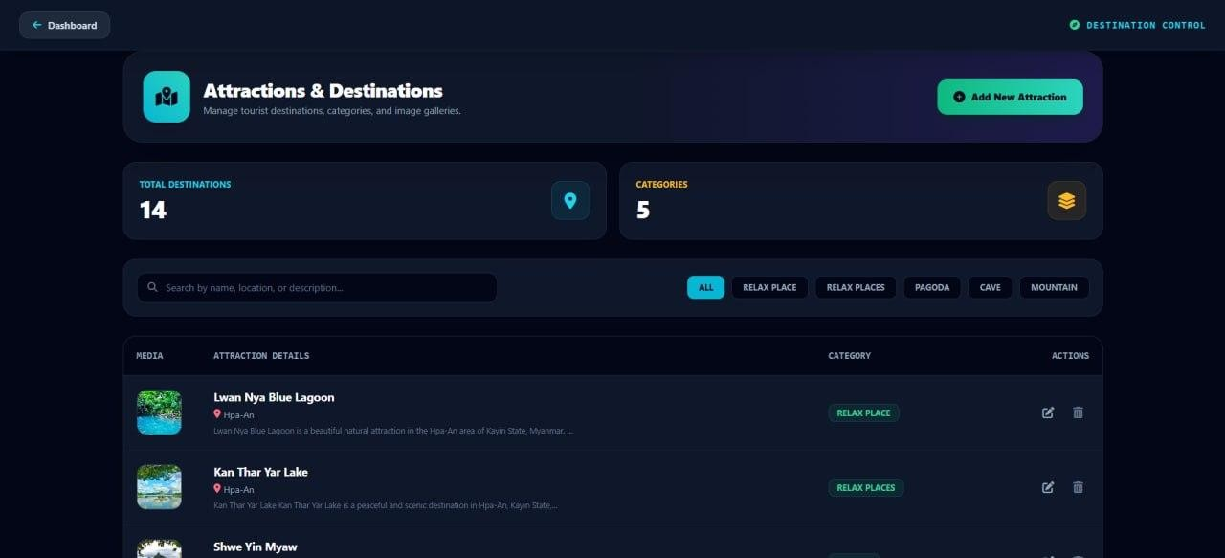
Figure(3.8): Management Attraction Page

Manage Hotel Room Page
In this Figure(3.9), the administrator can manage hotel Room, including adding, updating, and deleting hotel Room Record.
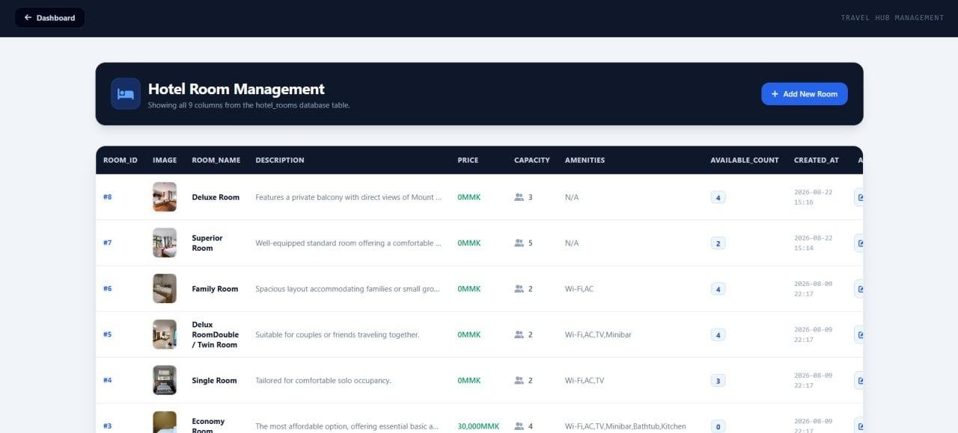
Figure(3.9): Manage Hotel Room Page

View Customer Rating Page
In this Figure(3.10), the administrator can view customer ratings and delete ratings when necessary.
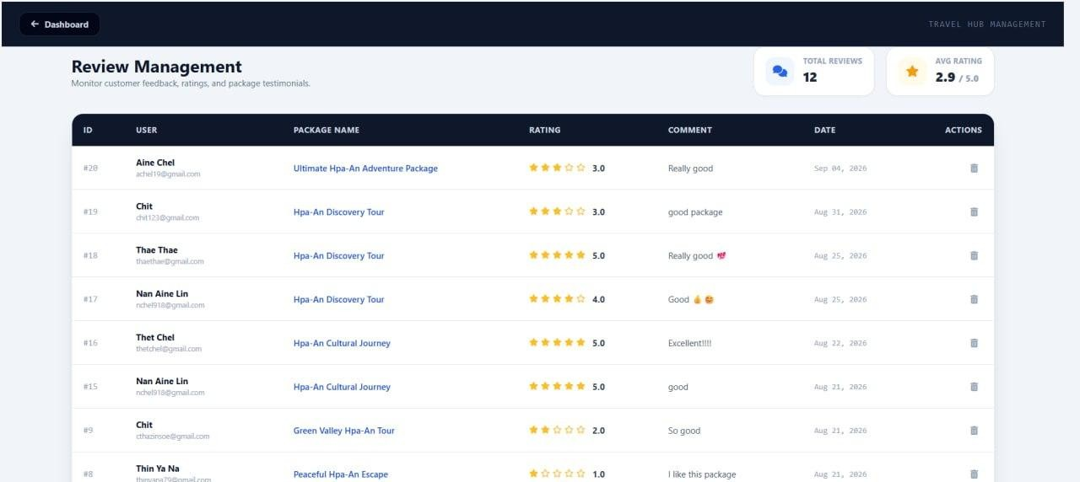
Figure(3.10): View Customer Rating Page

User Registration Page
In this Figure(3.11), users can register for an account by providing their information and log in to access their accounts.
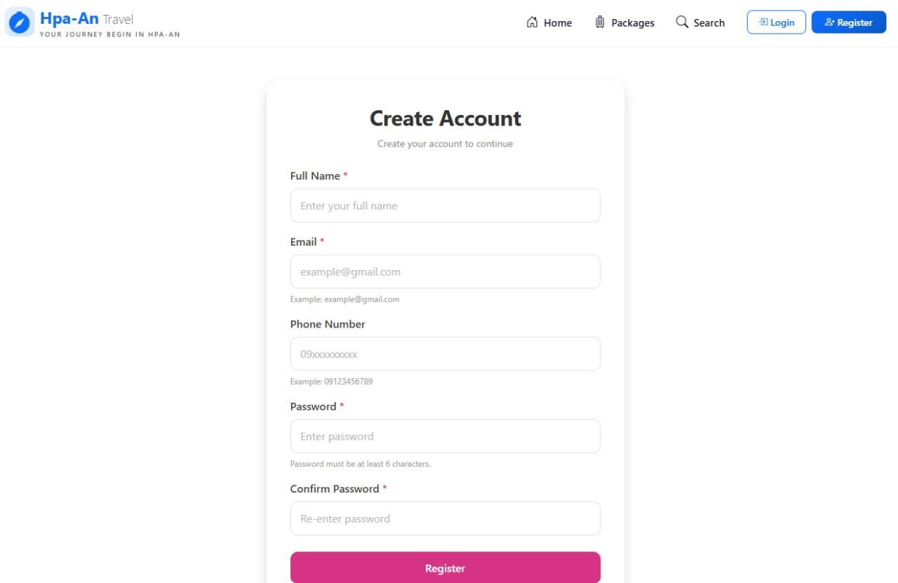
Figure(3.11): User Registration Page

User Login Page
In this Figure(3.12), the Users of this system could login into this page by entering Email and password.
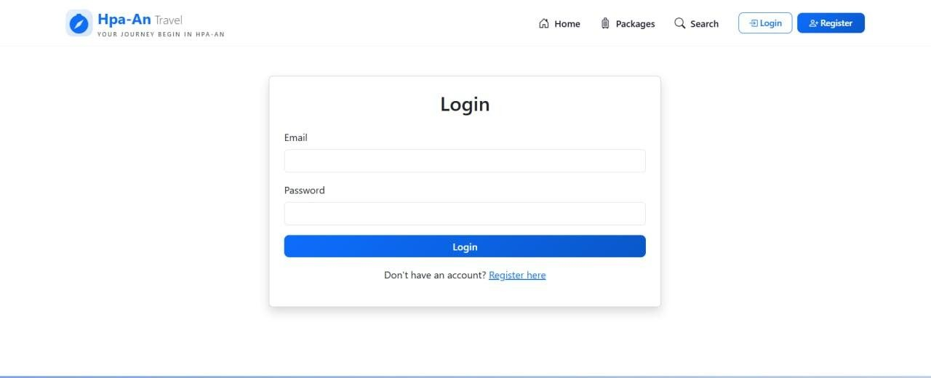
Figure(3.12): User Login Page

User Search Package Page
In this Figure(3.13), users can search for suitable travel packages based on trip duration, category, and budget. Users can select their preferred criteria and click the “Search Packages” button to view matching travel packages.
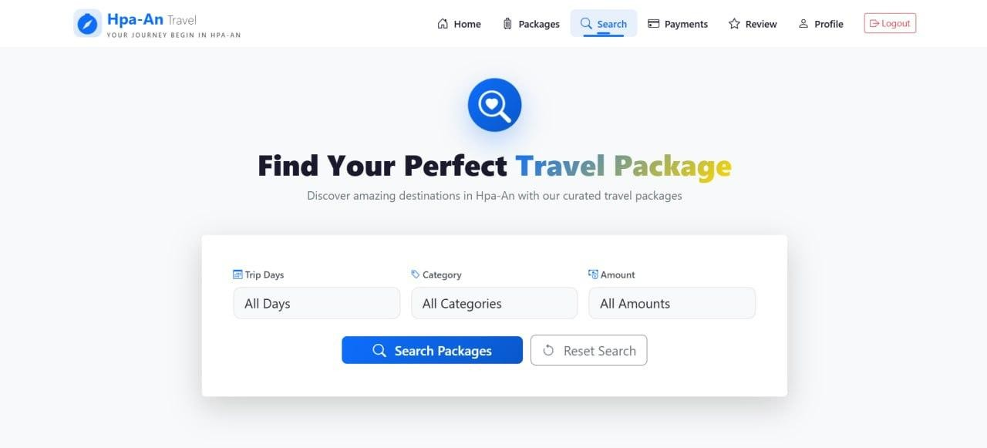
Figure(3.13): User Search Package Page

Travel Packages Page
In this Figure(3.14), users can view the available travel packages, including package names, destinations, prices, trip duration, categories, and maximum capacity. Users can also view detailed information about each package by clicking the “View Details” button.
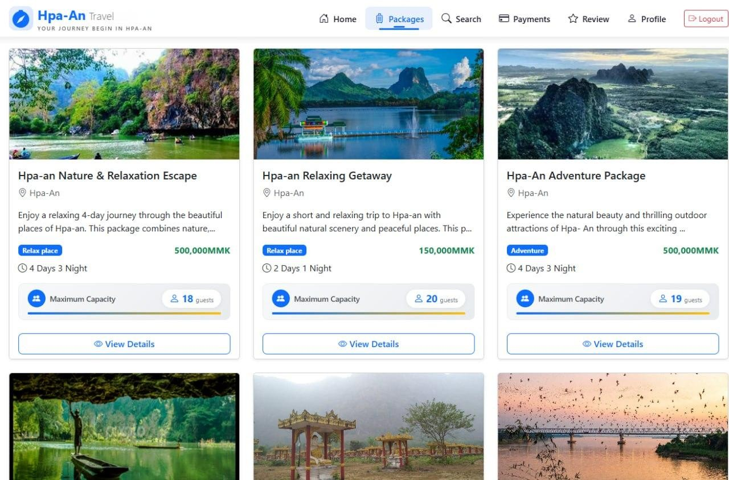
Figure(3.14): Travel Packages Page

Travel Package Detail Page
In this Figure(3.15), users can view detailed information about a selected travel package, including the package name, destination, duration, category, price, images, and customer review
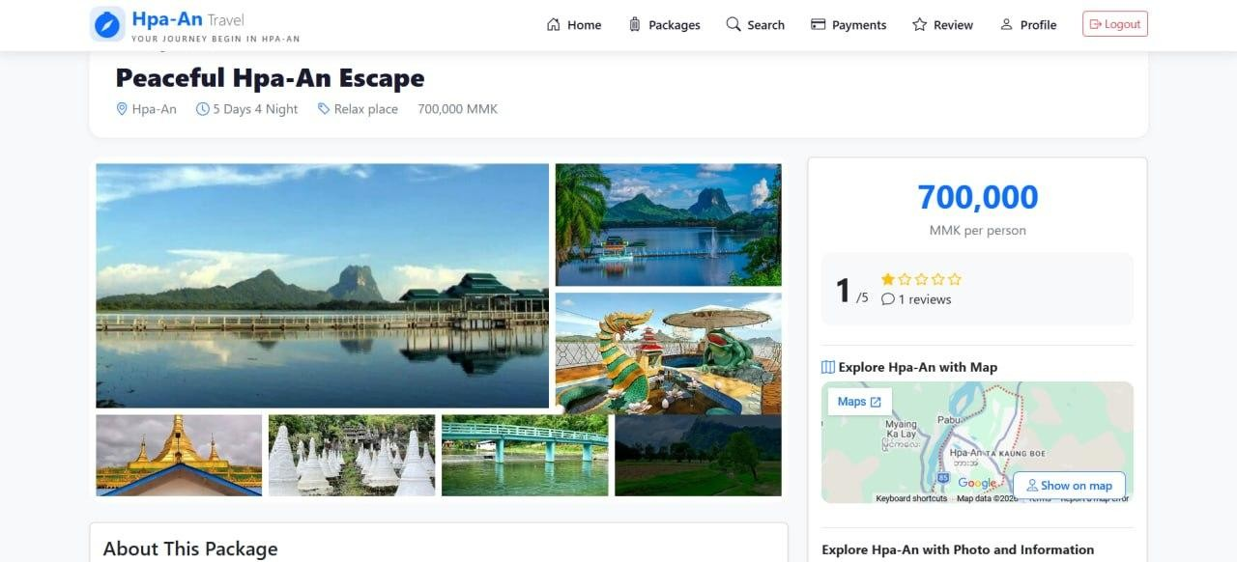
Figure(3.15): Travel Package Detail Page

Travel Places Map
In this Figure(3.16),users can also explore the destination location on the map and view additional information about the package.
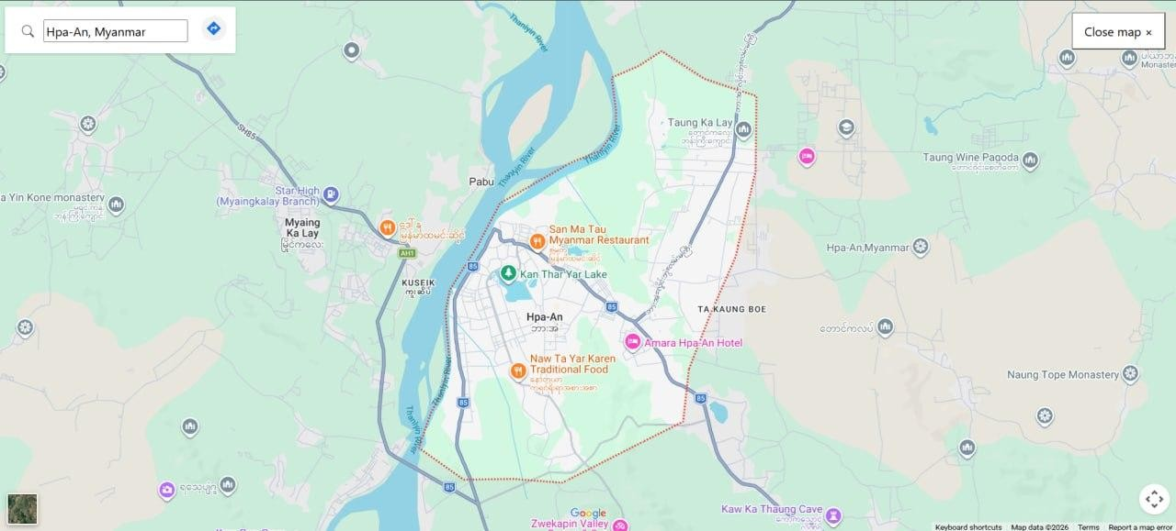

Figure(3.16): Travel Places Map

Explore Attraction Place's Knowledge
In this Figure(3.17), users can view detailed information about the selected destination, including its attractions, cultural significance, activities, and nearby places of interest.
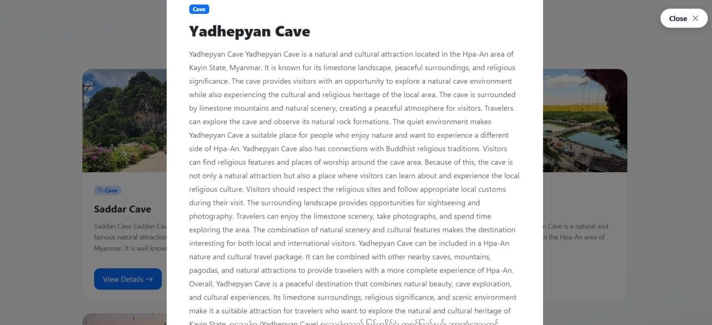
Figure(3.17): Explore Attraction Place's Knowledge

Explore Beauty Of Hpa-an Page
In Figure(3.18) ,the users can explore the Beauty of Hpa-an .

Figure(3.18): Explore Beauty Of Hpa-an Page

Figure(3.18): Explore Beauty Of Hpa-an Page

Select Hotel Page
In this Figure(3.19),users can select a preferred hotel or guest house from the available accommodation options based on their travel package.
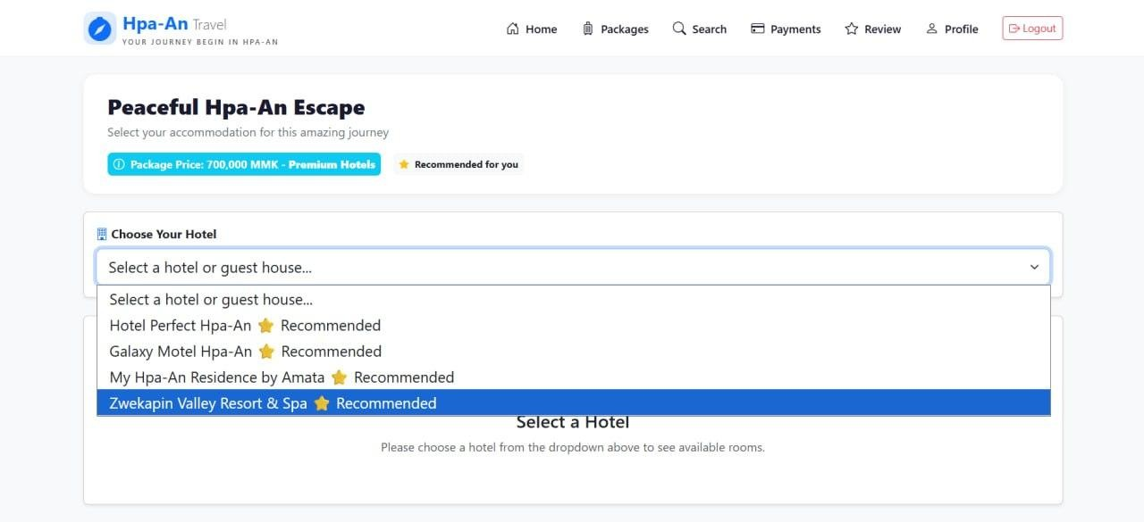
Figure(3.19): Select Hotel Page

Selected Hotel Detail Page
Users can view detailed information about the selected hotel in Figure(3.20).
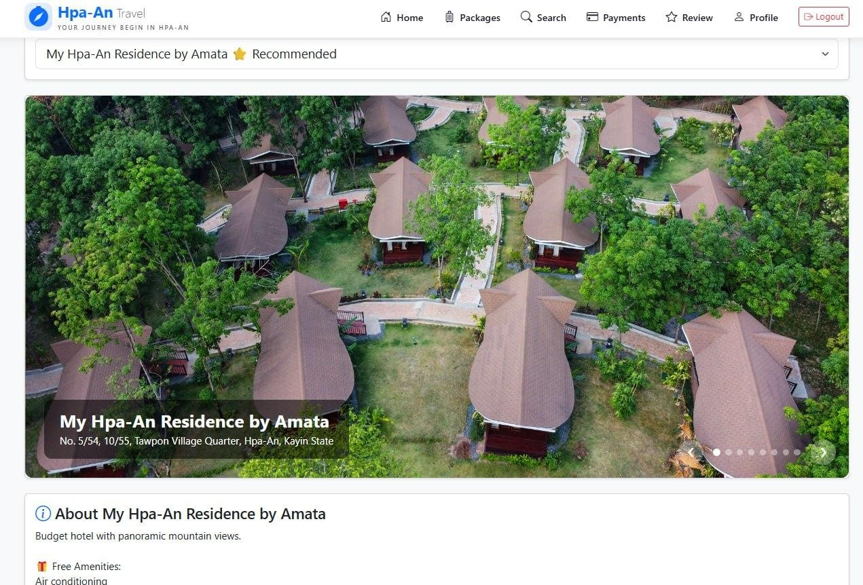
Figure(3.20): Selected Hotel Detail Page

Selected Hotel Room Page
In Figure(3.21), users can view the available hotel rooms of the selected hotel, including room types, prices, and other relevant room details.
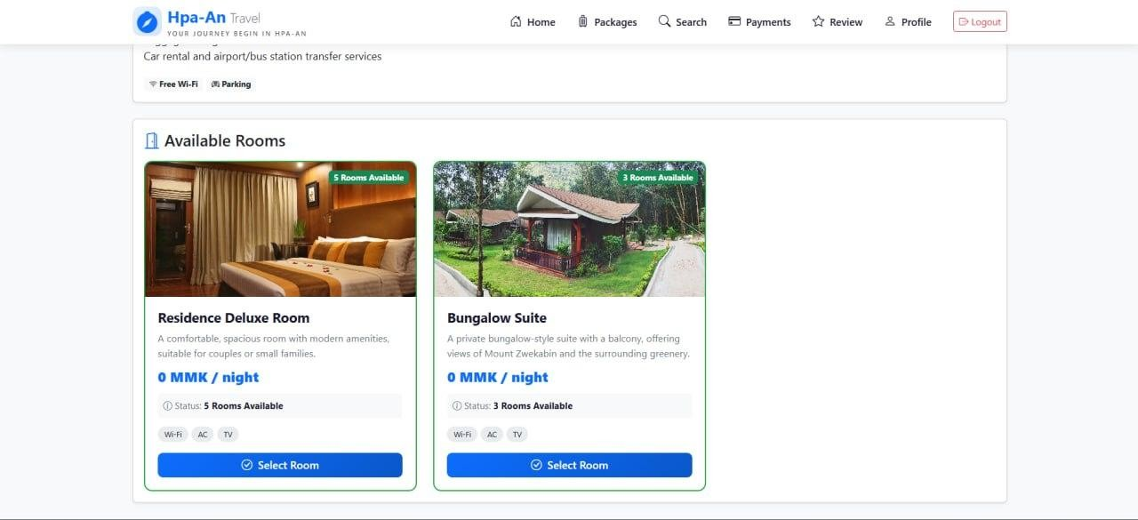
Figure(3.21): Selected Hotel Room Page
After selecting a hotel room, the system asks the user whether they want to add an extra bed.
If the user selects “Yes,” an additional charge of 30,000 MMK is added to the total cost.
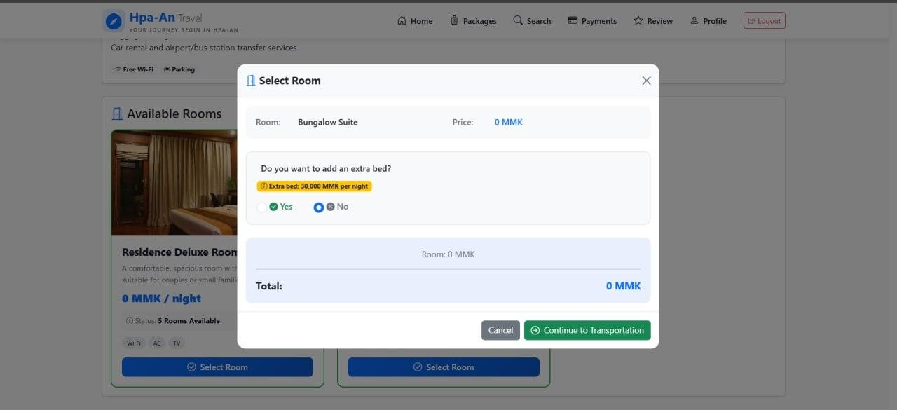

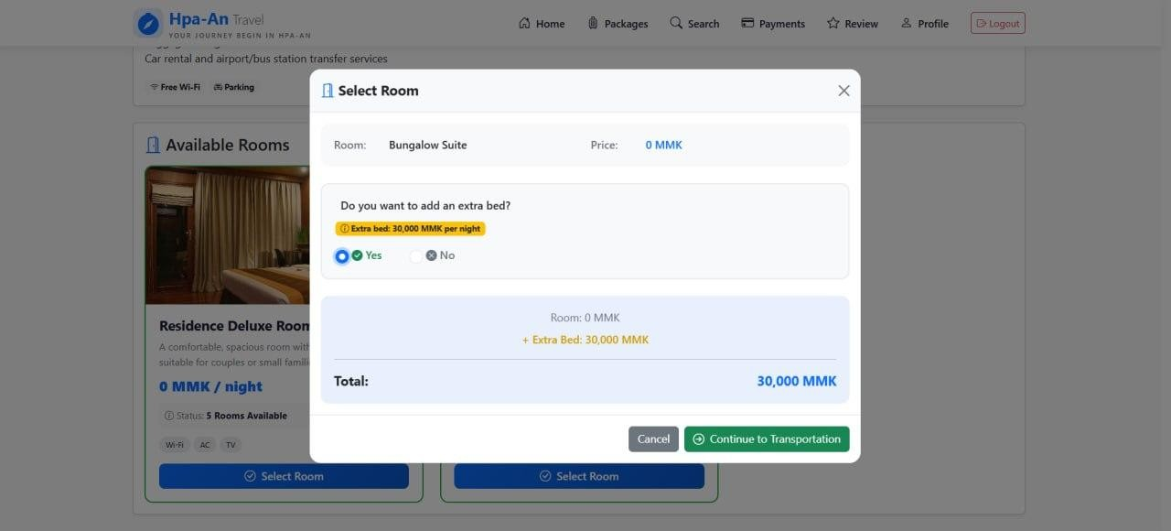
Figure(3.21): Selected Hotel Room Page

Select Transportation Page
In this Figure(3.22), Users can choose their preferred transportation option based on their travel needs and then proceed to the payment page to complete the booking process.
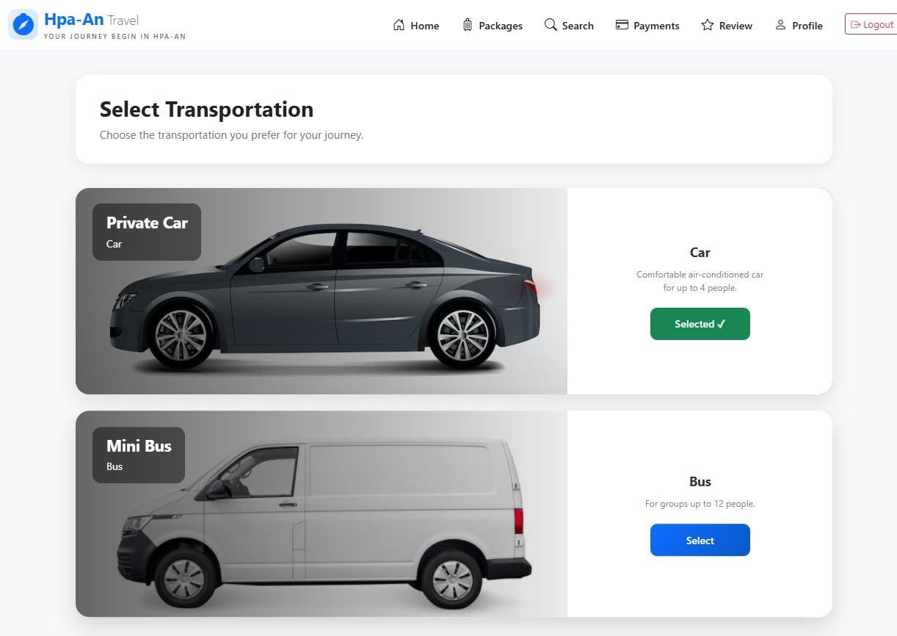
Figure(3.22): Select Transportation Page

User Payment Page
In this Figure(3.23), users can make payments by selecting the number of travelers, travel date, and payment method. The system also allows users to upload a payment slip and review the package, accommodation, transportation, and total cost before submitting the payment.
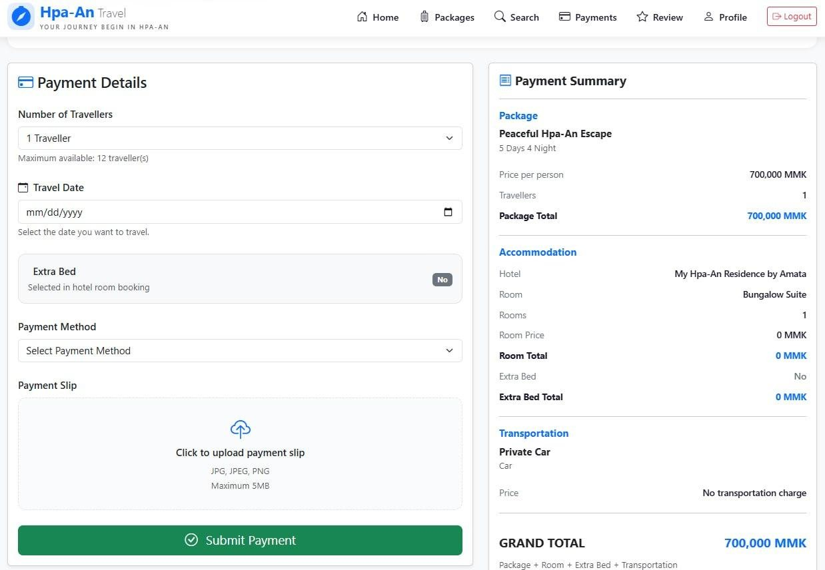

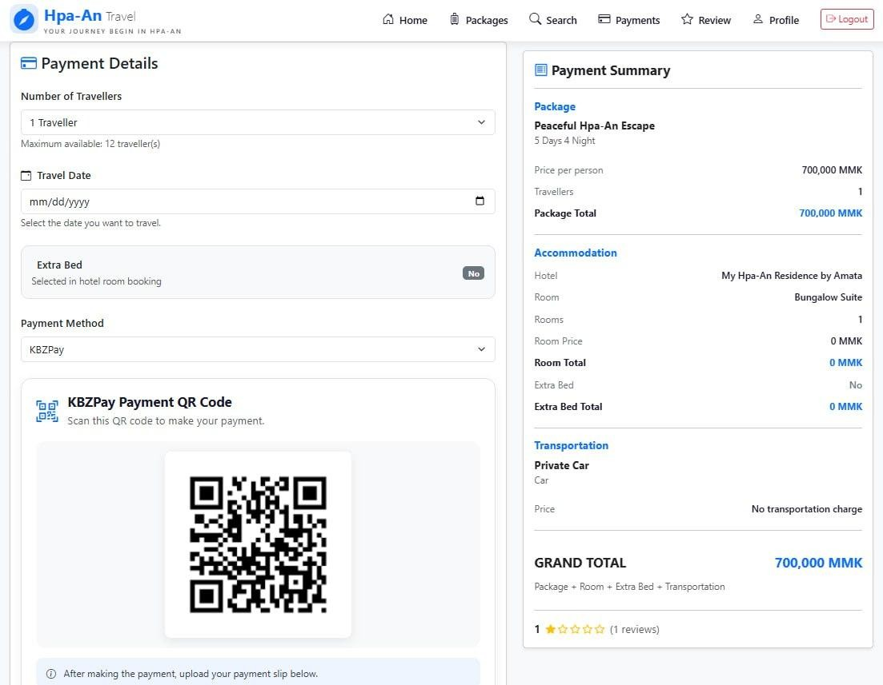
Figure(3.23): User Payment Page

User Payment History Page
In this Figure(3.24), users can view their payment history, uploaded payment slips, payment details, and payment status, including pending, approved, and rejected payments.
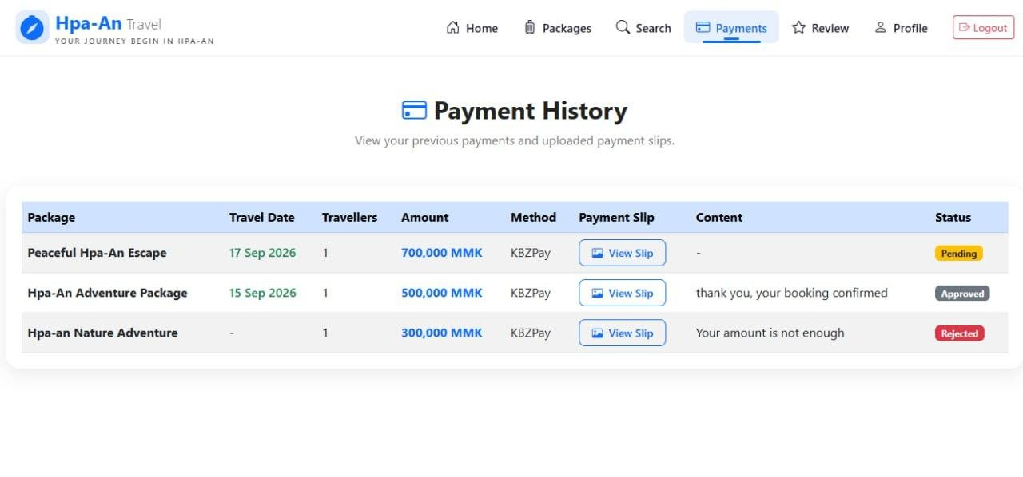
Figure(3.24): User Payment History Page

User Rating and comment Page
In this Figure(3.25), users can provide reviews and ratings for the travel packages they have purchased. This feature allows users to share their experiences and feedback about the package.
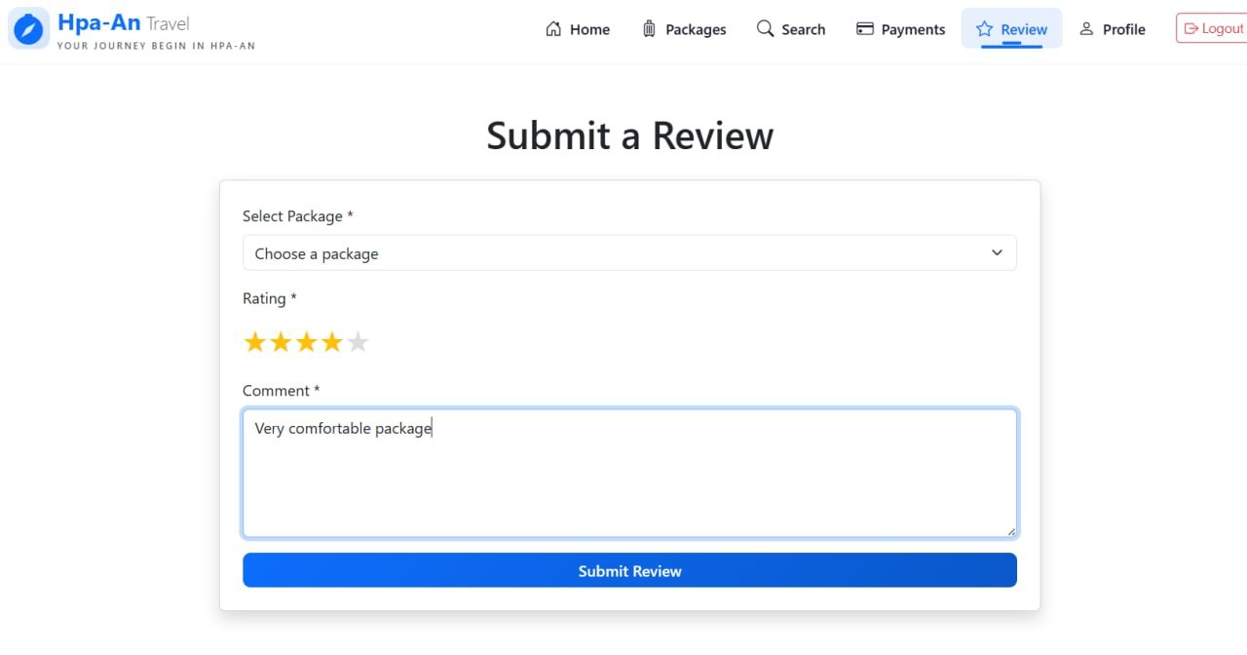
Figure(3.25): User Rating and comment Page

Chapter (4)

4.1 Conclusion
The Hpa-an Travel Packages Management System was developed to provide an efficient, userfriendly, and modern platform for managing travel packages and tourism services. The system allows tourists to browse travel packages, view package details, select accommodations and transportation, make bookings, and submit payments online. At the same time, administrators can manage travel packages, hotels, transportation services, bookings, and customer information through a centralized management system.This project helps reduce the limitations of traditional manual booking processes by improving accuracy, reducing paperwork, and saving time for both customers and administrators. The integration of online booking and payment features enhances convenience and accessibility for users. Furthermore, the system promotes tourism in Hpa-an by providing comprehensive information about travel destinations and available services.
Overall, the Hpa-an Travel Packages Management System successfully achieves its objectives of improving travel management efficiency, enhancing customer satisfaction, and supporting the digital transformation of tourism services. Future improvements may include mobile application support, real-time booking availability, online payment gateway integration, and personalized travel recommendations using artificial intelligence technologies.

REFERENCES
- PHP Documentation. Available at: https://www.php.net/docs.php
- PostgreSQL Documentation. Available at:https://www.postgresql.org/docs/
- Mozilla Developer Network (MDN) Web Docs. Available at:https://developer.mozilla.org/
- Ministry of Hotels and Tourism (Myanmar) – Kayin State Tourism Information. Available at:
https://tourism.gov.mm/en/regions/kayin
- Visit Kayin Tourism Portal. Available at: https://www.visitkayin.com
- Hpa-An Travel Guide Brochure, Ministry of Hotels and Tourism. Available at:https://admin.tourism.gov.mm/storage/Brochures%20and%20Pamphlets/210x135mm_Hpa
An_Brochure.pdf
- My Hpa-An Residence by Amata Hotel. Available at:https://www.amatahotelgroup.com/hotels/amata-my-hpa-an-residence
- Kawgun Cave Information, Visit Kayin Tourism Committee. Available at: https://www.visitkayin.com/index.php/en/destination/kawgunn-cave

